Many programs, interventions, services, and systems are put into place in higher education with the purpose of improving the academic performance of the students enrolled. Many of these programs work together in order to maintain and grow student attendance, persistency and retention. A common question occurs to upper administration in whether or not a program or system is having a positive effect on student outcomes. Because of the lack of access to private information in higher education, these questions are much harder to explore. As an internal study, I have taken this unique opportunity to explore whether disability services have a positive effect on the GPA outcomes of disabled students. It can be argued that disability services have the goal to help students who have disabilities achieve more than they would have without systemic support.

The Southern Utah University Disability Resource Center provides academic accommodations to students who experience academic limitations connected to a documented disability in accordance with the Americans with Disabilities Act. This study measures the effect that disability services have on student GPA outcomes.

Typically students who use disability services are the students who formally request testing accommodations in the DRC. I sampled 537 students who were enrolled in the Spring 2021 semester that were registered for disability services. Each student in this study had a proven disability and experienced some level of verified academic limitations in order to qualify for services. Of these students, 33% were identified into the treatment group while 66% students were identified as the control group. The treatment group represented students who had a proven disability who utilized atleast 1 testing accommodation during the treatment period. The control group represented students who had a proven disability but had never utilized testing accommodations. Ensuring that the students in the control group are proven to have a disability is essential to this analysis as this will allow us to remove potential bias between the treatment and control groups.

The Data

The Southern Utah University Disability Resource Center provides students who are enrolled at the university equal access to higher education through the application of accommodations in accordance with the Americans with Disabilities Act. In order to effectively and efficiently service the students who are registered with the center, the DRC must collect certain pieces of demographic, medical, psychological and academic information. This information is used with the sole purpose of ensuring that students who have a proven disability have equal access to higher education that students who do not have a disability do. Typically Accommodations range and vary based on substantial limitations connected to a diagnosis assigned by a medical or psychological assessment. Even though disabilities and accommodations vary between each individual student, all students who have a proven disability and are registered with the disability resource center can request testing accommodations through the disability resource center. For example, if a student is registered with the DRC, but do not require time extensions or isolated space, can still make a request to take an exam in the center. Because of this, this makes testing accommodations recorded in the DRC a great measure of services used by students. Typically, only students who actively use services make exam accommodation requests. Those who do not make exam requests typically represent a group of students who have registered for services but do not utilize them.

The Data in this study was collected by the DRC through the use of it’s in house data management system. The data is largely taken from medical assessments and forms filled out by the students at the time of registration with the center. In order for a student to be registered into the center, they will have had completed the process of providing documentation proving they have a diagnosed disability and have associated limitations that justify disability services. The specific data used in this analysis are defined in Table 1.

Table 1

|  |  |  |  |
| --- | --- | --- | --- |
| Variable Name | Description | | Type |
| treated | Students who utilized Exam accommodations | Binary | |
| tests taken | Number of exam accommodations used | Numeric | |
| Major | Major of the student | Categorical | |
| Overall GPA | The Overal GPA of the student | Numeric | |
| reg_credits | Number of credits registered in current semester | Numeric | |
| Gender | Gender of the student 1 = Male | Binary | |
| Age | Age of the student | Numeric | |
| Disability | The diagnosed disability category of the student | Categorical | |

The treated group in this analysis represents students who are registered in the DRC with a diagnosed disability who have utilized at least 1 testing accommodation in during the treatment period. In this case, the treatment period is the spring of 2021. The control group or untreated group represents students who are registered with a disability in the DRC but have not utilized any testing accommodations ever. Both the treatment and control groups are students who were registered with the DRC

The variable tests taken represent the summed total of exam accommodation requests made by the student. This information is collected from an online form the student voluntarily files each time they wish to take an exam in the center. Students who require an accommodation or perhaps require no accommodations are able to request to take their exams in the center. This variable represents the usage of disability services; as testing accommodations are the primary accommodation that students receive in the DRC.

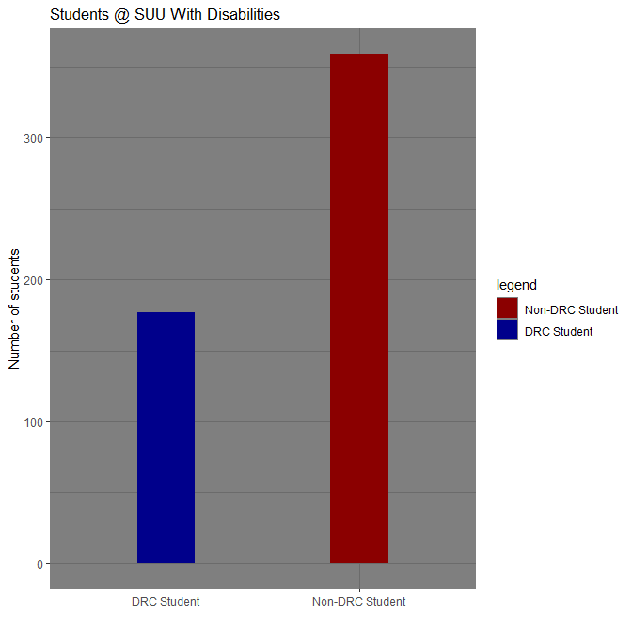

This information is gathered and updated from the university registrar and will be used in this study as a control for GPA. Major is primarily used as a control in order to take into account all disciplines which may be more difficult or less difficult than others depending on the student. Some argue that students in certain programs have higher or lower average GPA’s because of certain factors such as difficulty or the GPA requirements that may exist in individual programs. By including major, I hope to control for that bias.

Registered credits represents the total number of credits the student registered for during the treatment period. It is my hope to control for a students individual workload. This is because it could be argued that students who are taking higher course loads may struggle to maintain a higher GPA because of the higher demands on their time relative to students with lower registered credits. By including the registered credits we will hopefully control for this bias.

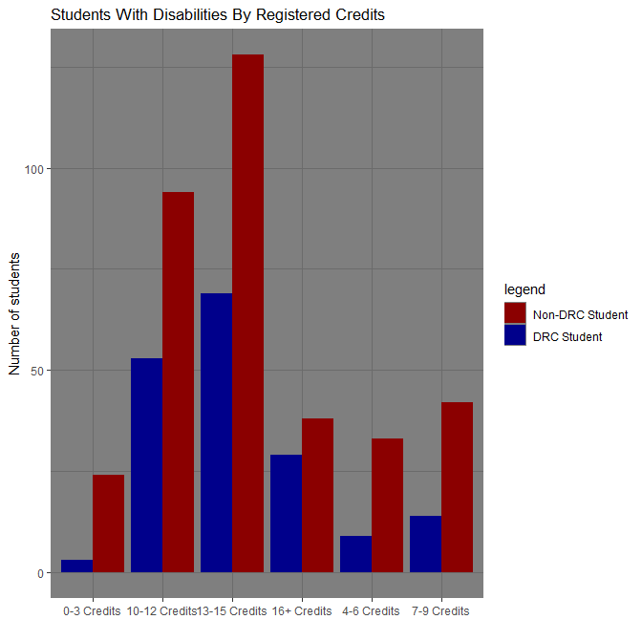

Demographic information such as age, gender and academic level are all collected by the student during their registration with the DRC. This information is updated each semester in order to reflect the students growth throughout their attendance at SUU. By including these variables I am hoping to control for any biases that may intrinsically influence GPA. As there are many studies that examine gender effects in higher education I chose to include these variables to control for some bias that may appear in the demographics of the student.

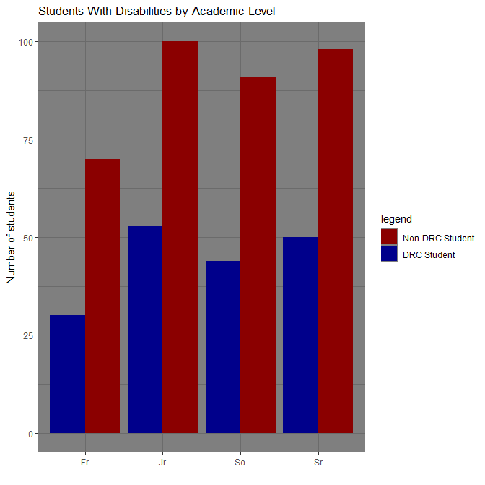

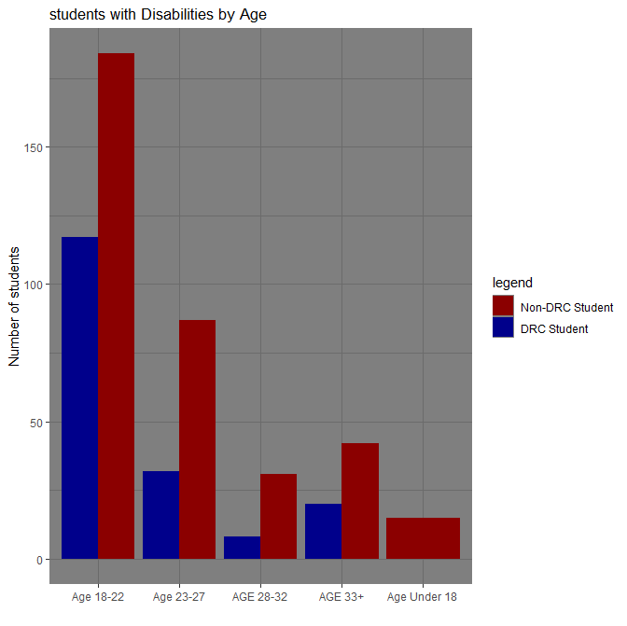

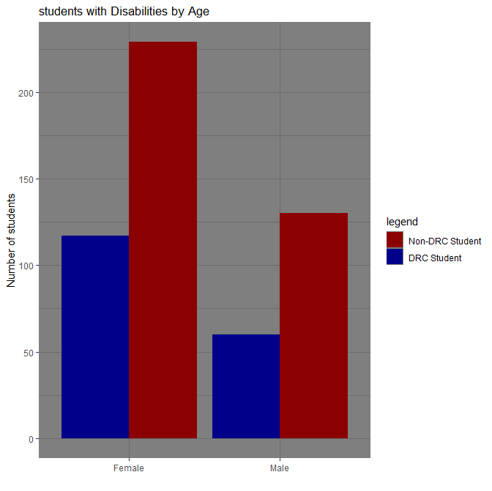

The variable Disability that is expressed in this study is recorded by the DRC at the time of registration. Observing the disability of the student as a control will hopefully control for the bias imposed by students differing disabilities which may limit them differently.

Our outcome variable for this study is Overall GPA. Overall GPA is used in this study as a measure of student outcomes. This GPA is reported after the treatment period and will be used in order to measure the effectiveness of testing accommodations on GPA. This is important as the DRC has a secondary mission to level the academic playing field for student insomuch that they can succeed and be retained as students. The reason I chose to use Overall GPA as opposed to Term GPA is that I hoped that by including a GPA that includes previous academic performance that would help control for the past academic performance of the student.

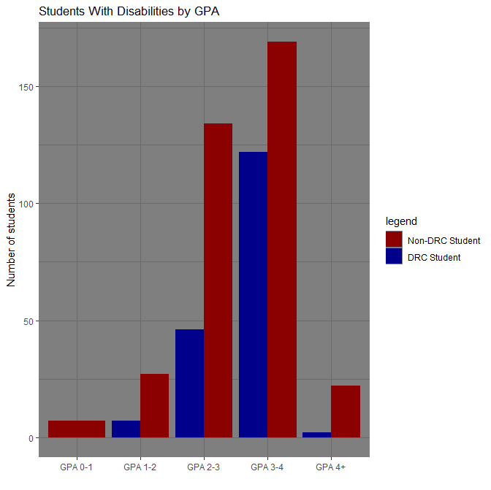

Summary of Raw Data

This table contains a summary of the data separated by the treatment and control groups:

Table 2

|  |  |  |
| --- | --- | --- |
|  | | |
| Descriptive Variable | Treatment | Control |
| Proportion in Group | 33% | 66% |
| Median Credits Registered | 13 | 12 |
| Average Age | 24 | 24 |
| Proportion Female | 88% | 76% |
| proportion male | 11% | 23% |

As represented in the table we can see that there are some similarities between the treatment and control group. For example, we can observe from this summary that out of the students registered for accommodations during the treatment period, only 33% utilized disability services for testing. It is important to note that the treatment period occurred during a time when exam restrictions and the need for testing accommodations were greatly lessened due to temporary alterations to the changes in teaching procedure during the coved19 Pandemic.

The students in both groups seemed to be enrolled in a similar volume of credits during the treatment period which may tell us that students in each group had a similar workload. As it can be argued that workload has a significant effect on GPA due to the fact that GPA is partly calculated by the number of credits taken it is important to our analysis that the registered number of credits be either close or exact to each other.

The average age of each group are summarized to be identical. This is potentially beneficial to our observation because we can assume that students in a similar demographic appear in our dataset. Some may argue that students may perform better or worse depending on traits such as age or maturity to effect GPA but here it seems that our groups fit into similar age groups.

The largest discrepancy in our data appears in gender. As seen in table 2 we can observe that in both groups there are significantly more females in our data. However after examining the population of the sampled data from the entire DRC dataset, it looks like there is a very similar male to female proportion in the population. With 61% females and 38% males in the population we can observe that the proportions in our treatment and control groups skew in a very similar fashion but perhaps not to the same extent.

Preliminary Conclusion of Report

We can see from the data above that we have a large amount of data collected from our control group. In order to proceed with analysis, I need to ensure that my treated and non treated groups are sufficiently comparable. Through the use of propensity score matching procedures, I will create a new dataset of students ho have similar features to students from the opposing group. This will allow our analysis to have a reduced amount of bias between the treated and non-treated groups.

Through the use of different modelling techniques we can observe the effect that Disability Services have on a students GPA. Prior to analysis we can see that the features of the students in our study seem to follow similar trends. However, one observation that needs to be mentioned is that there are a large amount of students who do not use Disability Services during the treatment period. I think that this is likely due to the dramatic increase in remote courses and a large amount of faculty removing time limitations from their exams or making exams entirely open book. Future observations should probably be used in a comparative analysis to this one. Furthermore, I would like to use additional analyses such as PCA to find other features that could be included in my analysis. There are several additional variables that can be populated and combined to explain more variation is these student’s GPA’s; with this additional information I could remove additional bias from my analysis.